Instructions for Preparing Camera-Ready Abstracts for ISHOC2022(Times new roman, 12 points, Bold, Centered)

First Author ^{(1,*)}, Second Author ⁽²⁾, and Third Author ^{(1,2)} (10 points, Times new roman, Centered. The presenting author is specified with an asterisk ^{(*)}.)

⁽¹⁾ Graduate School of Engineering, Hokkaido University, Kita13 Nishi8, Sapporo 060-8628, JAPAN (10 points, Times new roman, Centered.)

⁽²⁾ Department of Materials Science and Engineering, Muroran Institute of Technology, Mizumoto 27-1, Muroran 052-0035, JAPAN (10 points, Times new roman, Centered.)

e-mail: xxxx@aaaaaa.ac.jp (Times new roman, 10 points, Centered)

1. INTRODUCTION (Times new roman, 10 points, left aligned)
(Abstract body: Times new roman, 10 points, not indented)Authors should prepare gray-scale camera-ready abstracts using this template file, which will be printed in an Abstract Book in the same size. The abstract page should have margins of 25.4, 16, 21.6 and 16 mm for top, bottom, left, and right in the A4 size. The values were already applied to this template file. The page length must be 2-4 page that may include tables and figures.
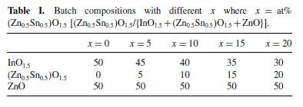
The manuscript components are:
1. INTRODUCTION,
2. EXPERIMENTAL,
3. RESULTS AND DISCUSSION,
4. CONCLUSION,
Acknowledgements,
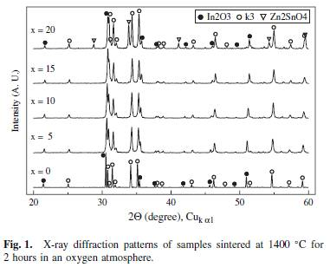
and References.
Paragraphs are not indented, but are separated with a blank line.

Figures and tables files are embedded in the manuscript as gray-scale images. Acceptable graphic file formats are EPS (preferred), TIFF, PSD, and JPEG (high resolution only). The resolution of the files should be 300 dpi.

References are indicated by brackets as [1], [2,3], or [4-6] in manuscripts. Then they are listed at the end of the manuscript using the format shown next.
References (Times new roman, 10 points, left aligned)
- Downey, D. F. et al, Ion Implantation Technology, Prentice-Hall (New York, 1993), pp. 65-67. [A book reference …]
- Wasserman, Y., “Integrated Single-Wafer RP Solutions for 0.25-micron Technologies,” IEEE Trans-CPMT-A, Vol. 17, No. 3 (1995), pp. 346-351. [A reference to a journal article …]
- Shu, William K., “PBGA Wire Bonding Development,” Proc 46th Electronic Components and Technology Conf, Orlando, FL, May. 1996, pp. 219-225. [A reference to a presentation at a Conference…]
- P.H. Ralston and G.B. Hatch, U.S. Patent 3,803,038 [patent example]
- A “private communication” or “unpublished research” may be referenced when required to give proper credit. The citation must include the affiliations and addresses of the persons involved.

